1. **Scope**:

The purpose of this document is to provide the guidelines necessary to design and implement software that fulfills all the requirements given.

* This document covers all the functions provided by the webapp.
* This document covers the workflow of each functionality
* This document covers the architectural details of the webapp
* This document covers the data models and schema for all the data tables used
* This document covers the technologies used in the project development
* This document covers the security architecture
* This document does not cover the planning and timeline related information
* This document does not serve as use documentation

1. **Architecture overview**

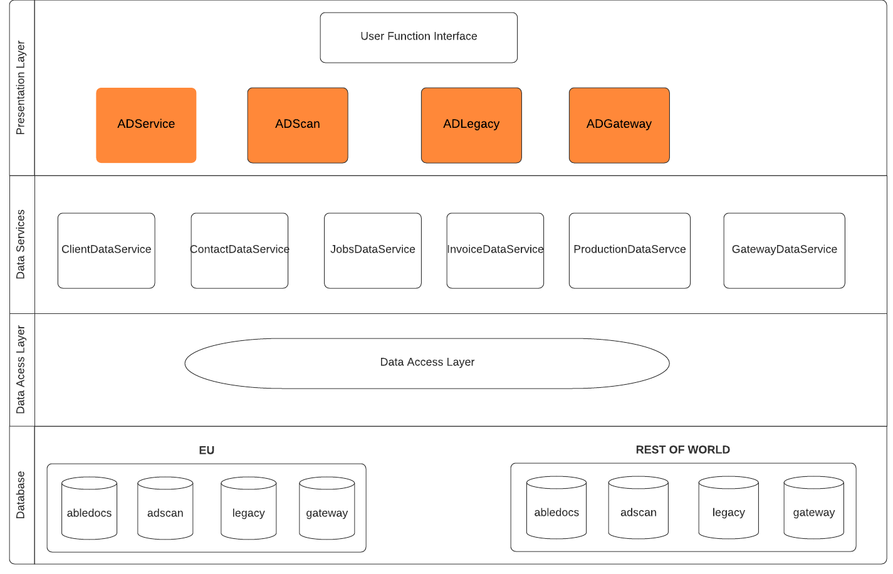

1. **Technology Used :**

* **ASP. Net Core with razor pages.**
* **MySQL Database**
* **AJAX Jquery**

1. **Data Model Description**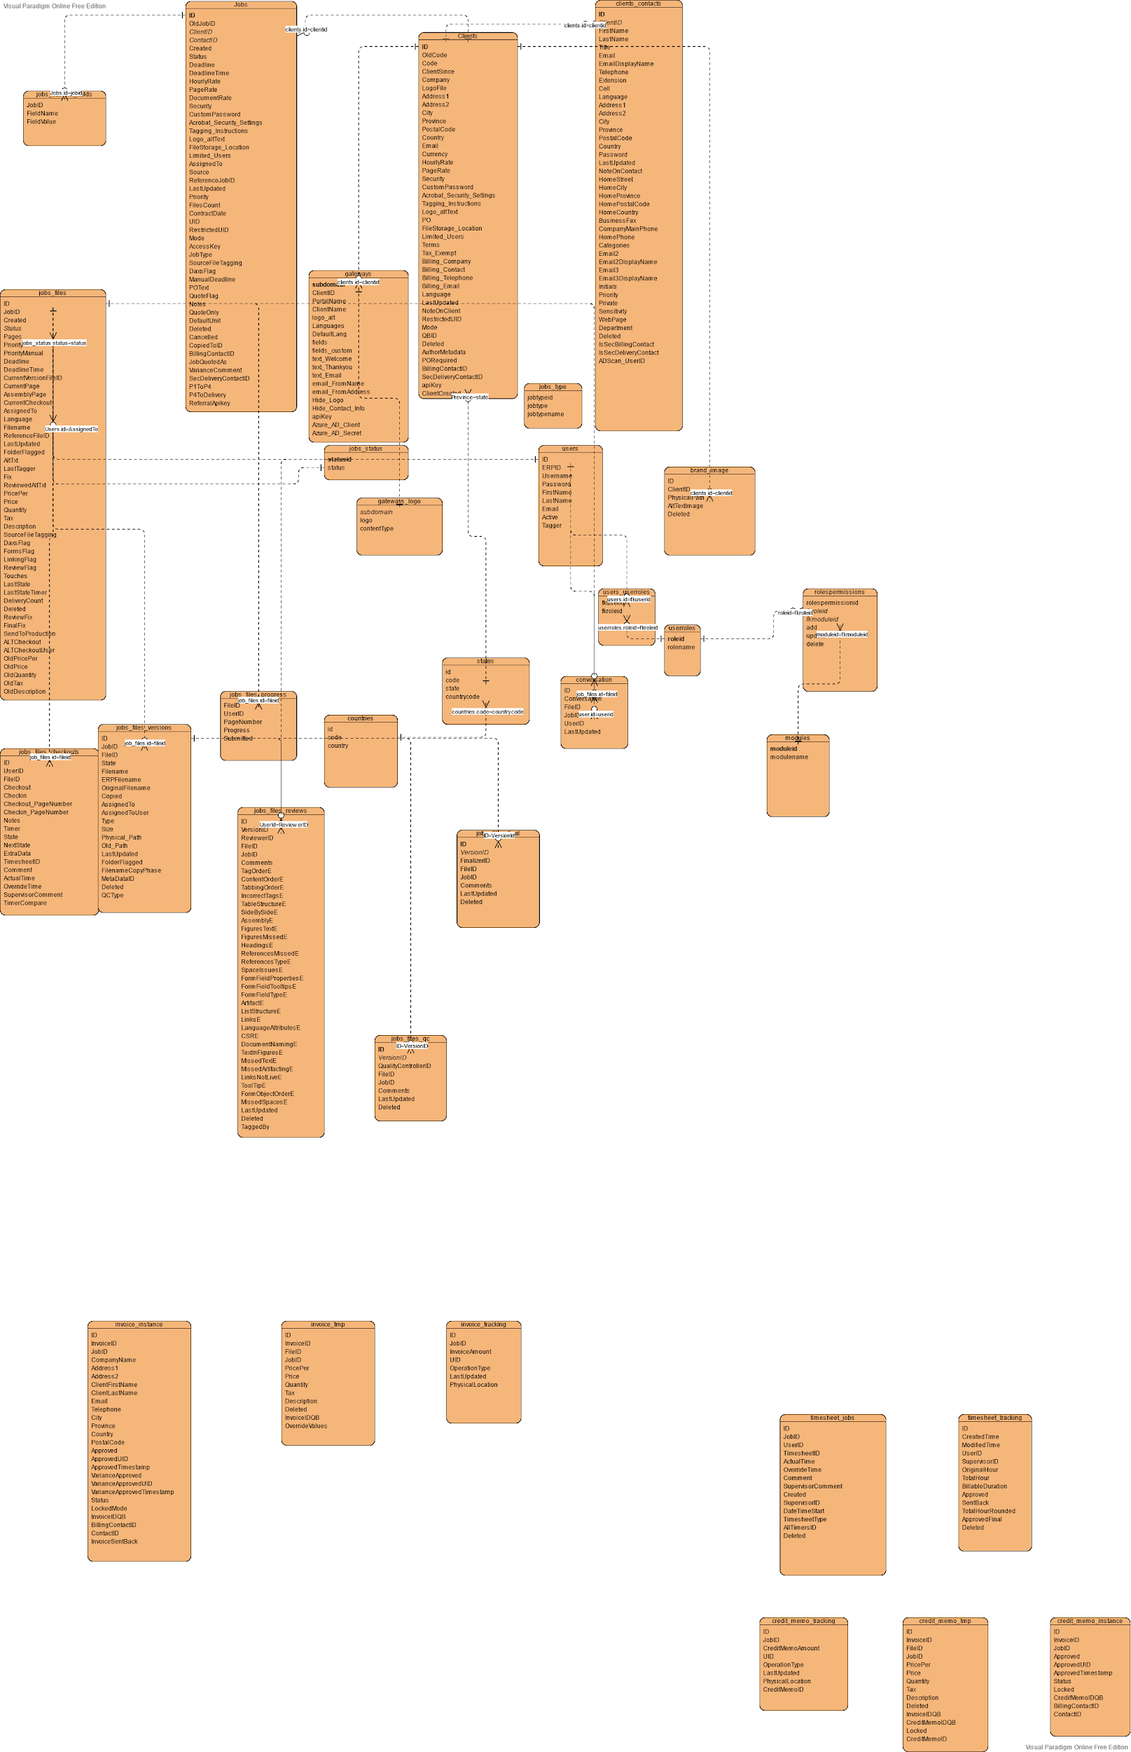
2. **External interface description**

Following are the GUI elements

**Jobs:**

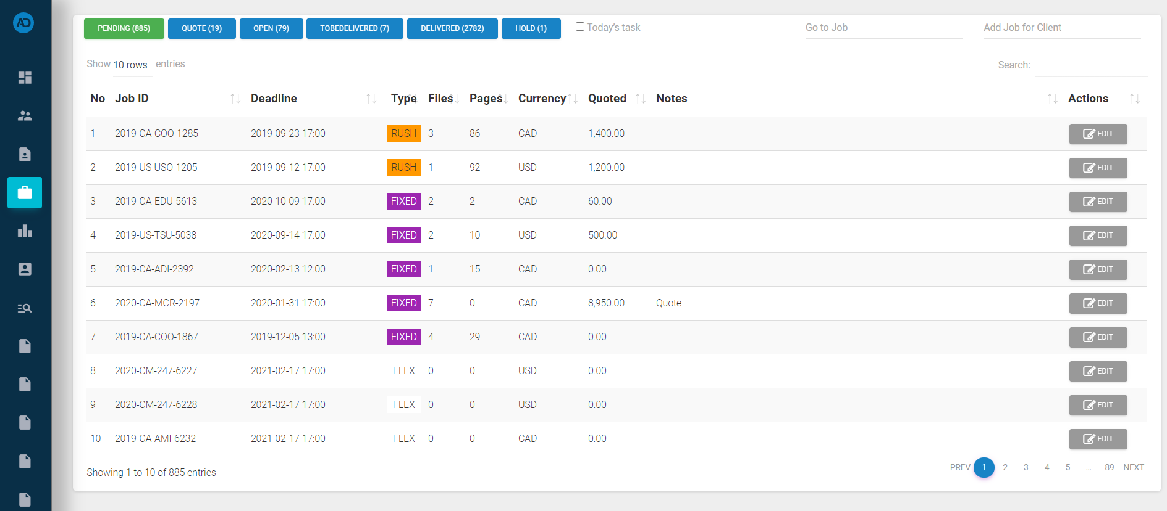

* **Job Dashboard: T**his location where all jobs are listed. There is provision for different status of the jobs. Pending, Quote, Open, To Be Delivered, Delivered and Hold are the status. The default selection is pending status. Here is the explanation of each status

Pending: New job created and its status is **pending.**

Quote: Quote is generated for this Job.

Open: Quote is approved and job is open.

To Be Delivered: Job task is completed and ready to be delivered.

Delivered: This job is delivered to the client.

Hold: This job is on hold

* **Job Details** :

Clicking on the Edit will open the job. Here the Job Details can be edited.

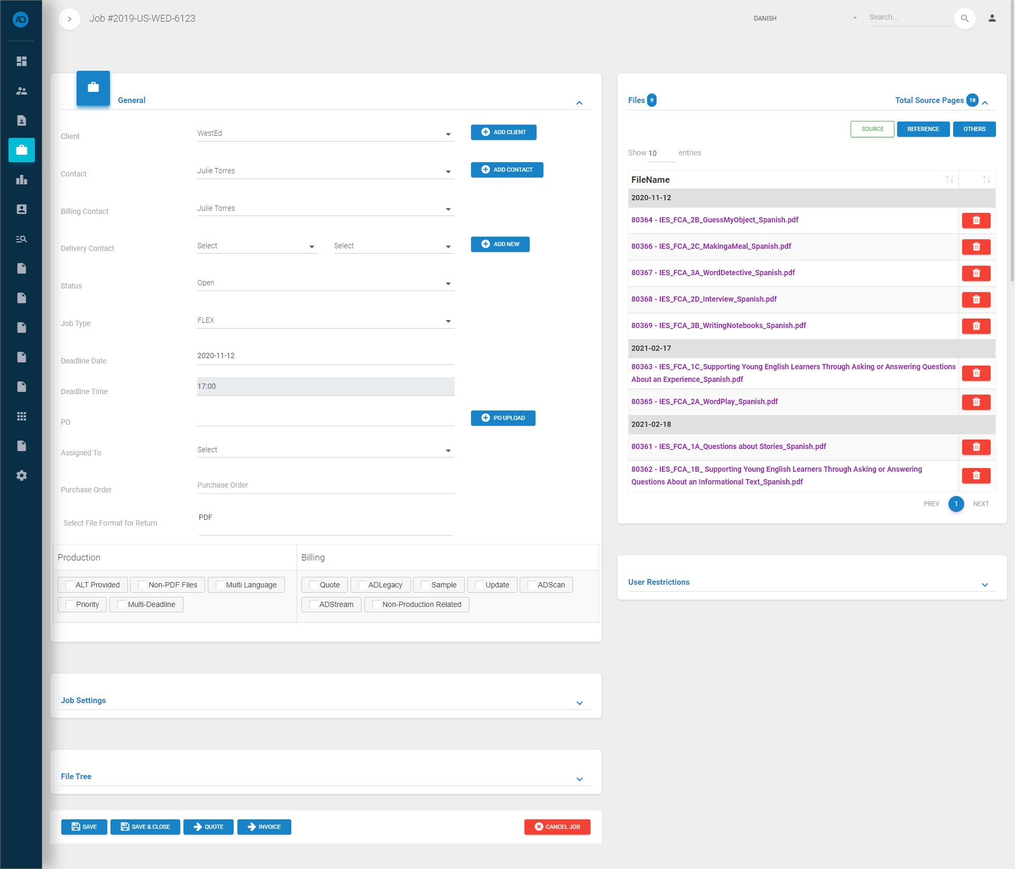

Following sections available in Jobs details page

* General:

Basic details of jobs shows in this section like Clients, Contacts details, Job Deadline date and time, Assigned to user, Production and Billing Flags.

* Job Settings :   
  This section contains the security settings like Security, Custom Password, Tagging instructions
* File Tree:   
  This section shows all files associated with this job. All jobs are grouped in different phases like phase 1, phase 2, phase 3, source, etc. Users are able to download all or selected files. Multiple files are downloaded in Zip format.
* Files: From this section users are able to upload files in three different categories: Source, Reference, Others.
* User Restrictions: Shows list of users allowed and restricted to this particular job.
* To be delivered Files: When job status is **ToBeDelivered**, This section is visible. From this section, users are able to select all files that need to be sent to clients with predefined email contents.  
  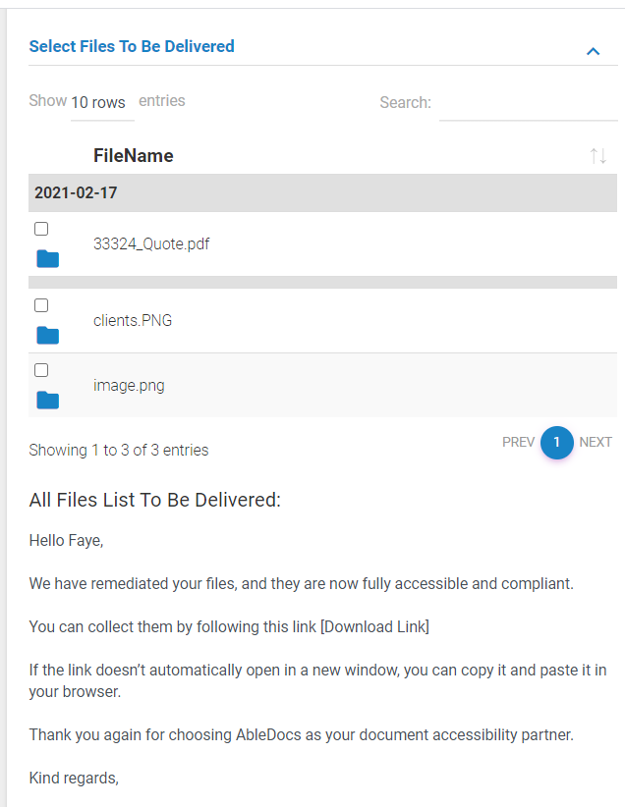
* **Quotes:**

Users can create quotes for a job. Quotes are generated based on client language and country location.

Quote have four sections :

* Heading : Heading title of a quote.
* Offering : All items offered in quotes.
* Notes : Notes to add in quote
* Details : Contain all items to be included in the quote.
* **Invoices:**

Users are able to create new invoices from quotes given. Invoice generated based on client language and country location.

**Clients:**

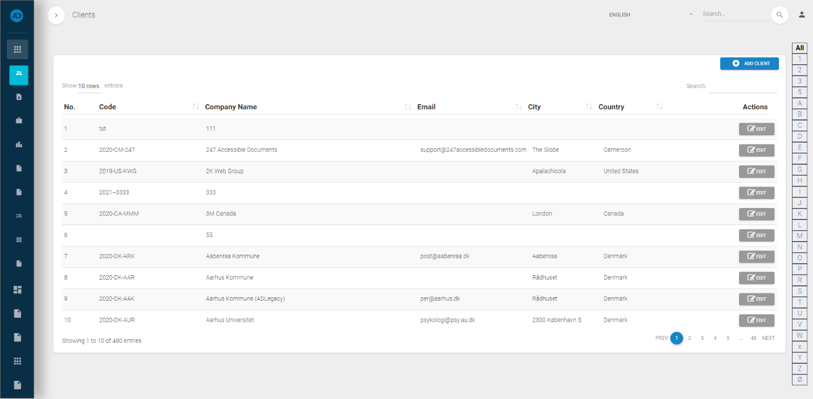

* **Clients Dashboard:** This location where all clients are listed. There is provision for alphanumeric filters of the clients.

ADD Client : To new client created.

* **Client Details** :

Clicking on the Edit will open the client. Here the Client Details can be edited.

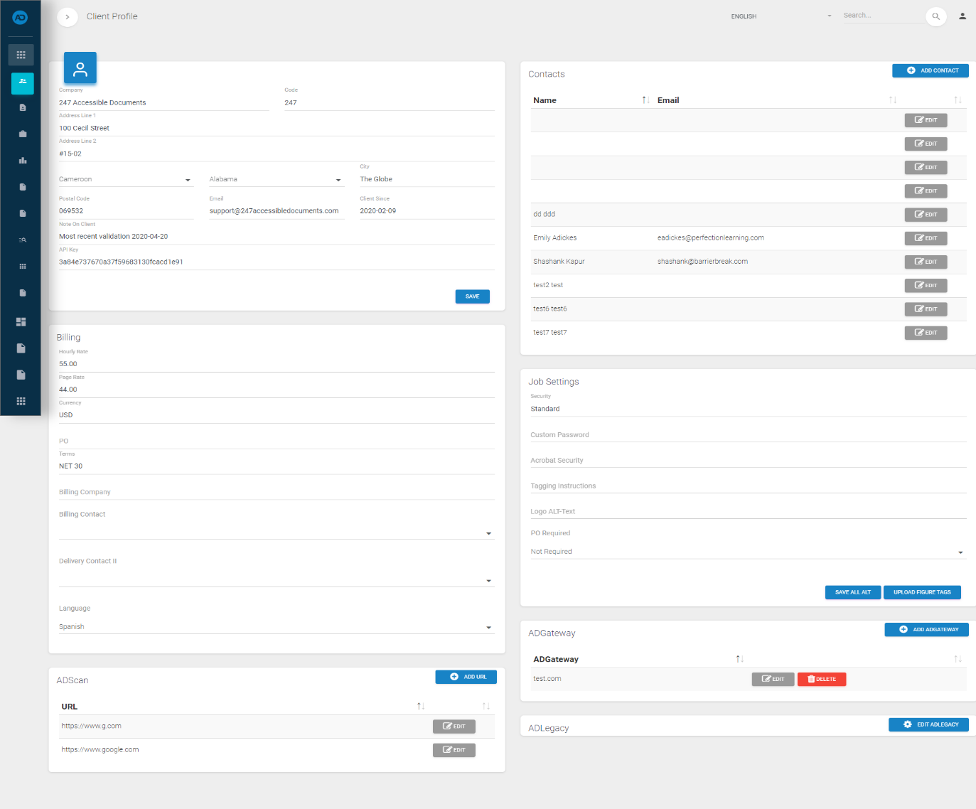

Following sections available in Clients details page

* General:

Basic details of clients show in this section like Company, Code, Address 1, Address 2, City, State, Country, Postal code, Email, Client since, Note on the client, API Key.

* Contacts :   
  This section shows all contacts associated with this client
* Billing :   
  This section contains the billing like Hourly rate, Page rate, Currency, PO, Terms, Billing Company, Billing contact, Delivery contact, Language
* Job Settings :   
  This section contains the security settings like Security, Custom password, Acrobat security, Tagging instructions, Logo alt text, PO required
* ADScan :   
  This section shows all adscan associated with this client
* ADGateway :   
  This section shows all adgetway associated with this client
* ADLegacy Details :

Clicking on the Edit adlegacy will open the adlegacy. Here the ADLegacy Details can be edited.

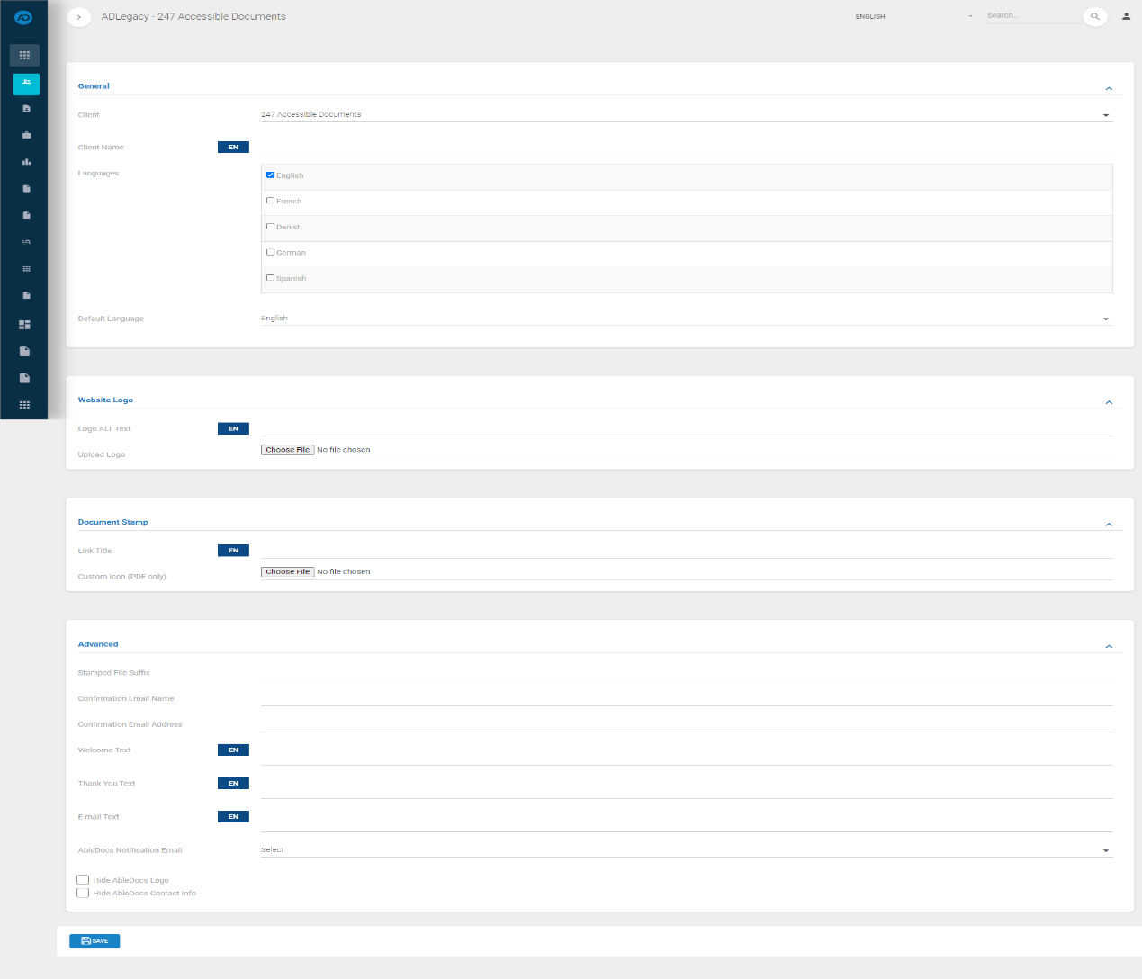

Following sections available in ADLegacy details page

* General:

Basic details of adlegacy shows in this section like Client, Client name, Languages, Default language.

* Website Logo :   
  This section contains the website logo like Logo alt text, Upload logo format of jpeg or png.
* Document Stamp :   
  This section contains the document stamp like Link title, Custom icon upload format of pdf.
* Advanced :   
  This section contains the advanced like Stamped file suffix, Confirmation email name, Confirmation email address, Welcome text, Thank you text, E-mail text, Abledocs notification email.

**Contacts:**

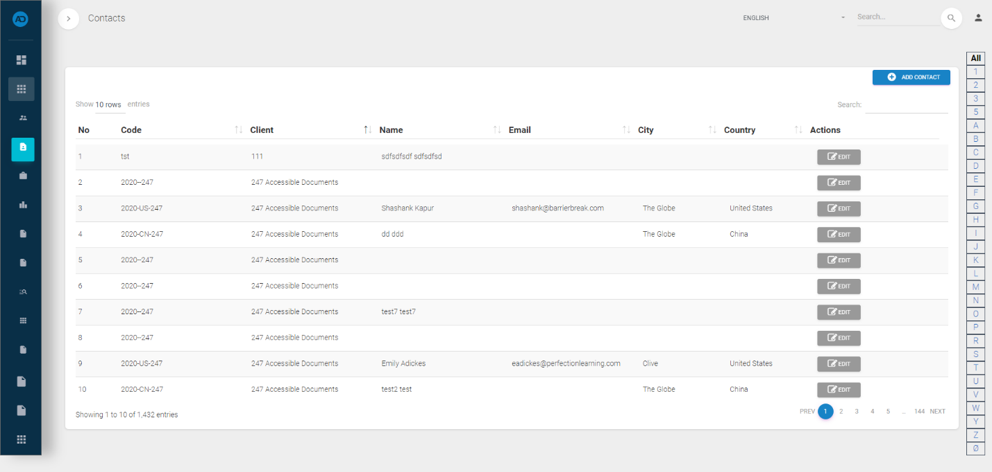

* **Contacts Dashboard:** This location where all contacts are listed. There is provision for alphanumeric filters of the contacts.

ADD Contact : To new contact created.

* **Contact Details** :

Clicking on the Edit will open the contact. Here the Contact Details can be edited.

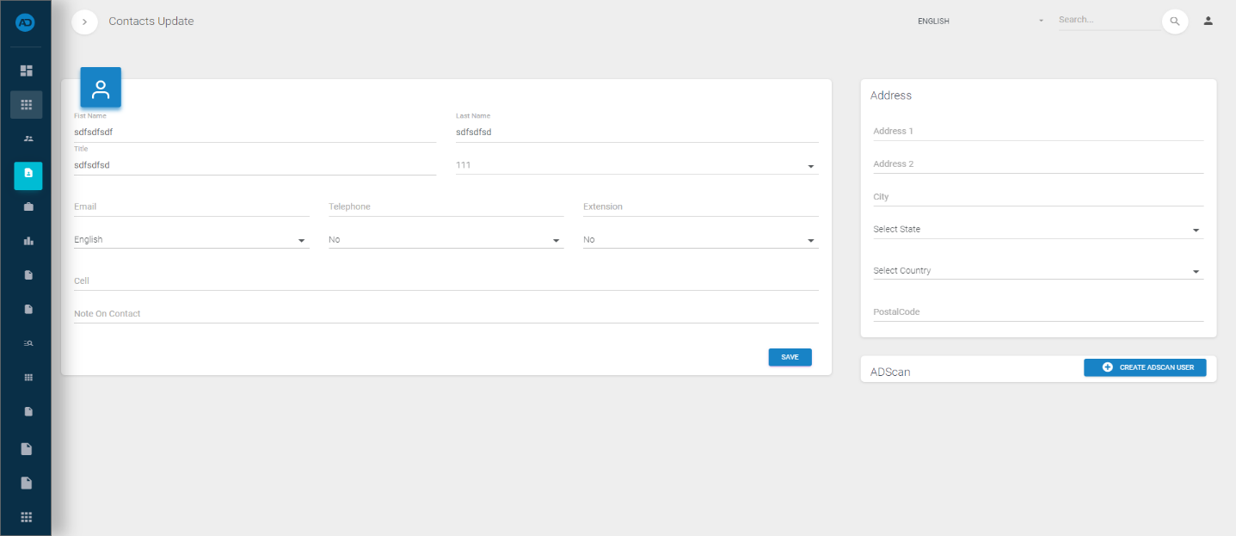

Following sections available in Contact details page

* General:

Basic details of contact shows in this section like First name, Last name, Title, Client, Email, Telephone, Extension, Language, Billing contact, Delivery contact, Cell, Note on contact.

* Address :   
  This section contains the address like Address 1, Address 2, City, State, Country, Postal code.
* Create ADScan User :   
  To new adscan user created.
* Reset ADScan Password :   
  To reset adscan password.

**Production:**

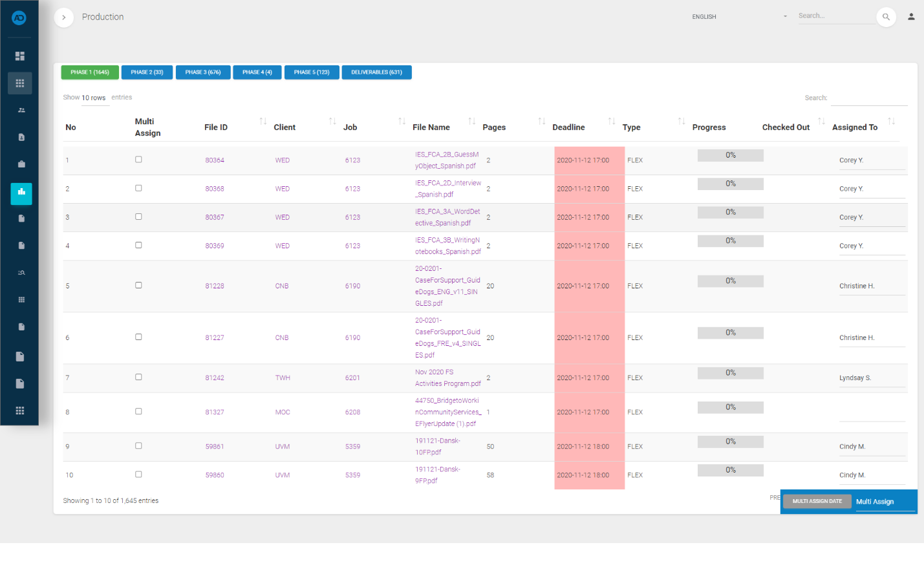

* **Production Dashboard:** This location where all productions are listed. There is provision for different status of the production. Phase 1, Phase 2, Phase 3, Phase 4, Phase 5 and Deliverables are the status. The default selection is phase 1 status. Here is the explanation of each status

Phase 1: Job files status is tagging**.**

Phase 2: Job files status is review**.**

Phase 3: Job files status is open**.**

Phase 4: Job files status is final**.**

Phase 5: Job files status is qc**.**

Deliverables: Job files status is to be delivered**.**

Multi Assign Date: Assign date to multiple files.

Multi Assign: Assign assigned to multiple files.

**Phase 1**

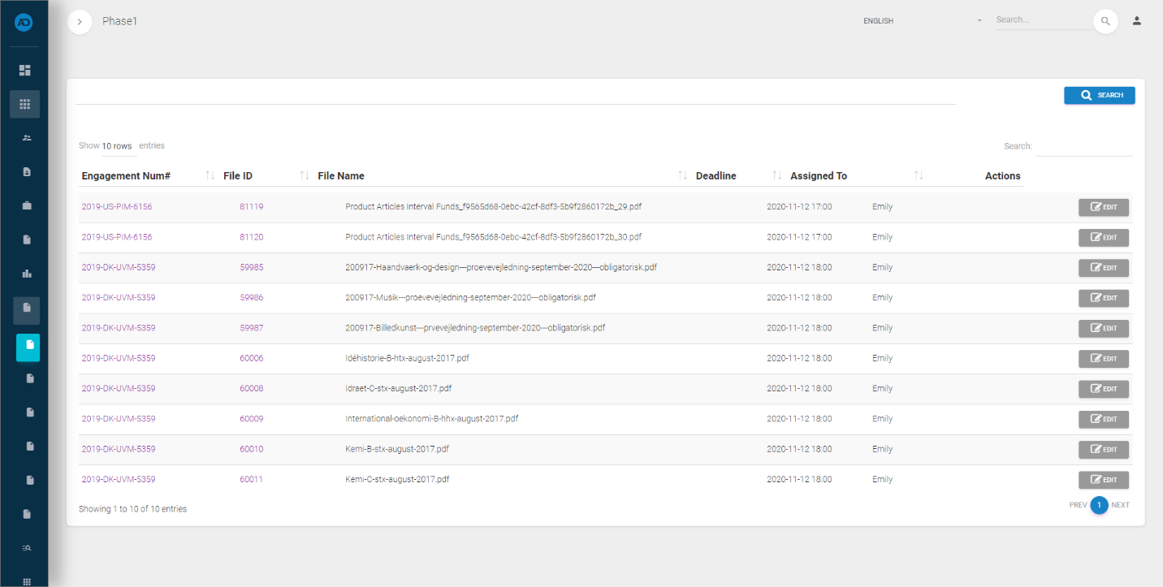

* **Phase 1 Dashboard**: This location where all files whose status is tagging are listed.

**Phase 2**

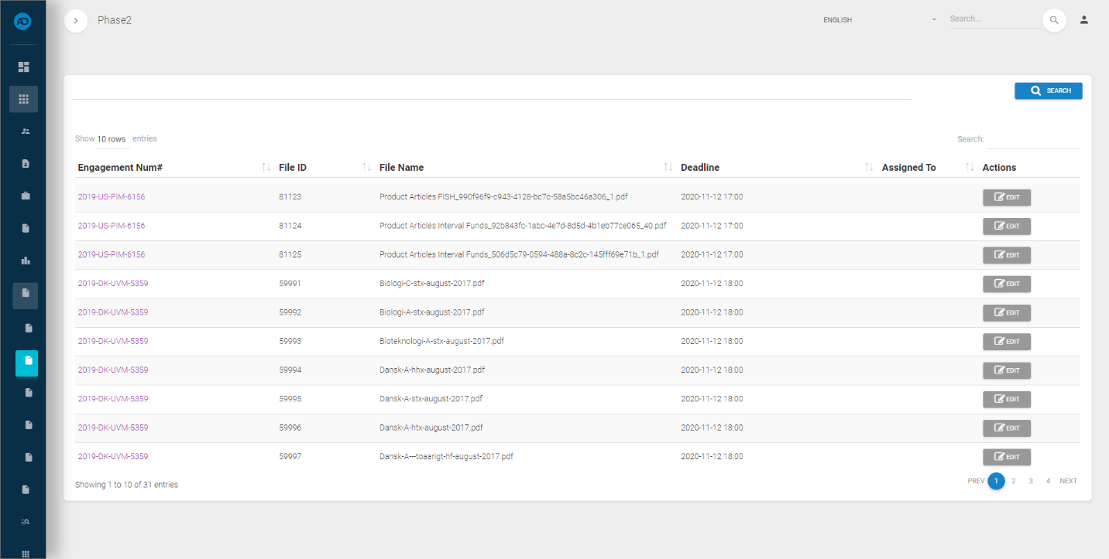

* **Phase 2 Dashboard**: This location where all files whose status is review are listed.

**Phase 3**

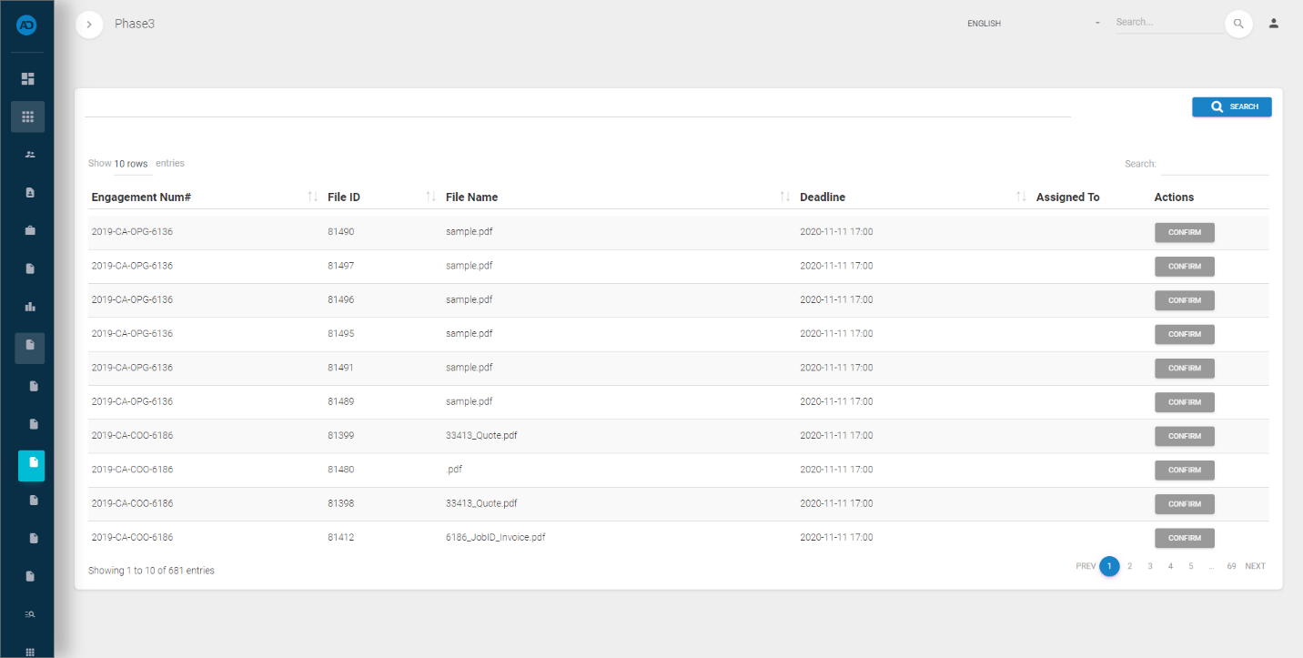

* **Phase 3 Dashboard**: It shows a list of files for Jobs which has status “Open” and files status not “Closed”, “Pending”.

**Phase 4**

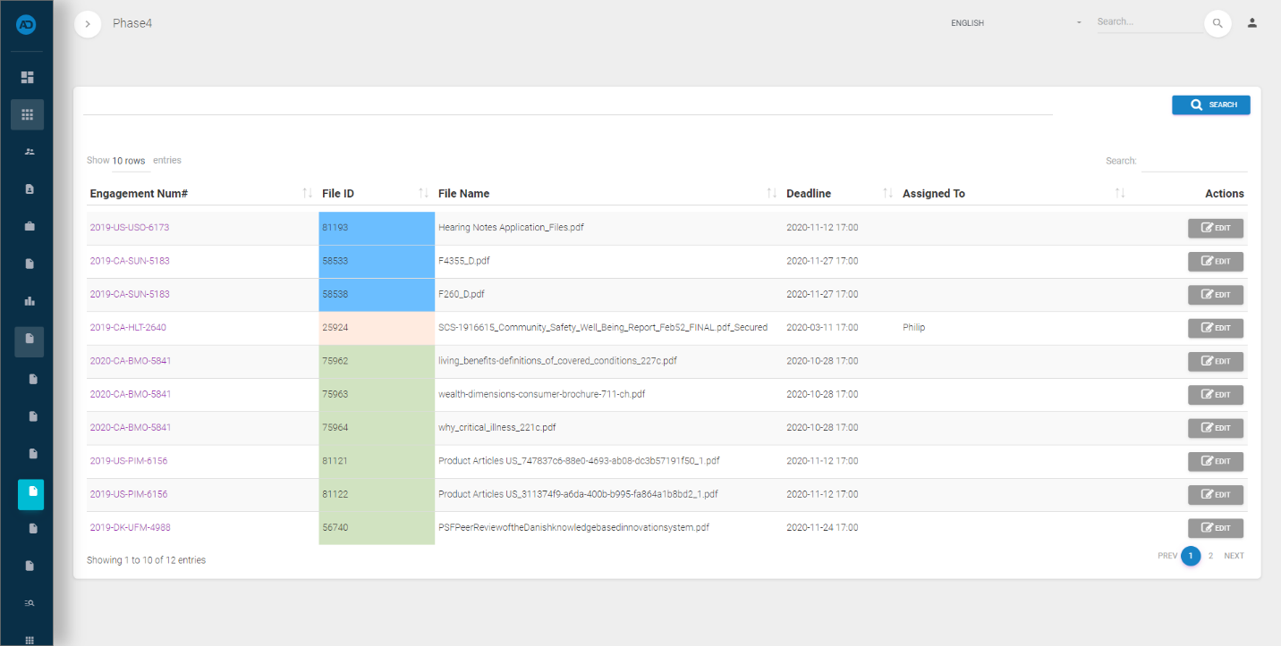

* **Phase 4 Dashboard**: This location where all files whose status is final are listed.

**Phase 5**

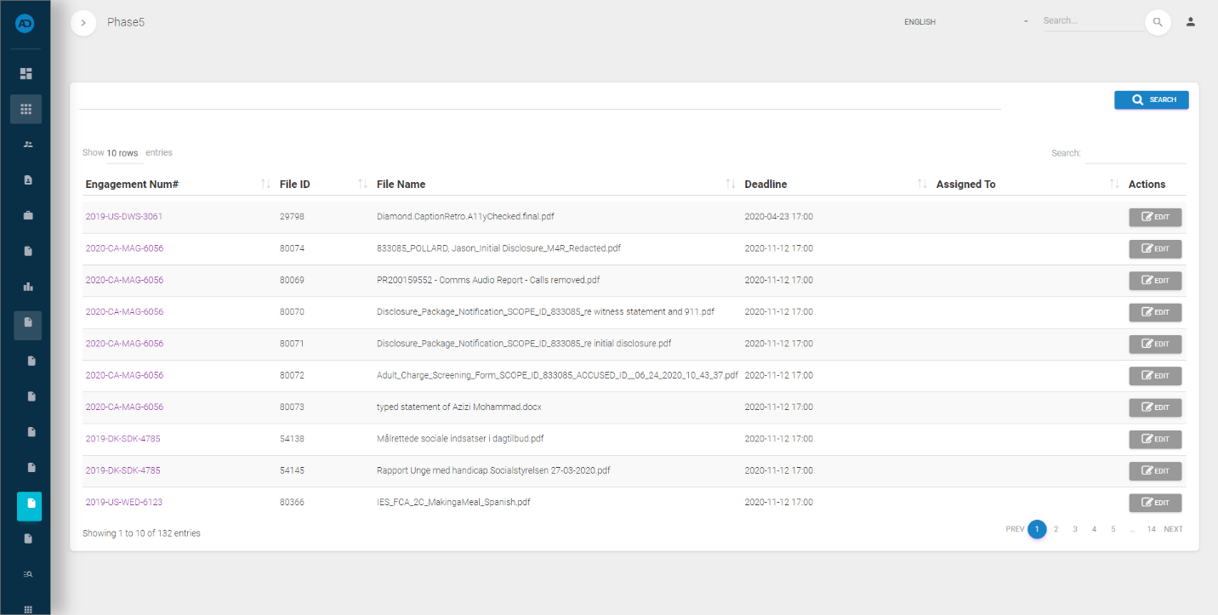

* **Phase 5 Dashboard**: This location where all files whose status is qc are listed.

**Phase 1, Phase 2, Phase 4, Phase 5**

* **Phase 1, Phase 2, Phase 4, Phase 5 Details** :

Clicking on the Edit will open the phase 1, phase 2, phase 4 and phase 5. Here the Phase 1, Phase 2, Phase 4 and Phase 5 Details can be edited.

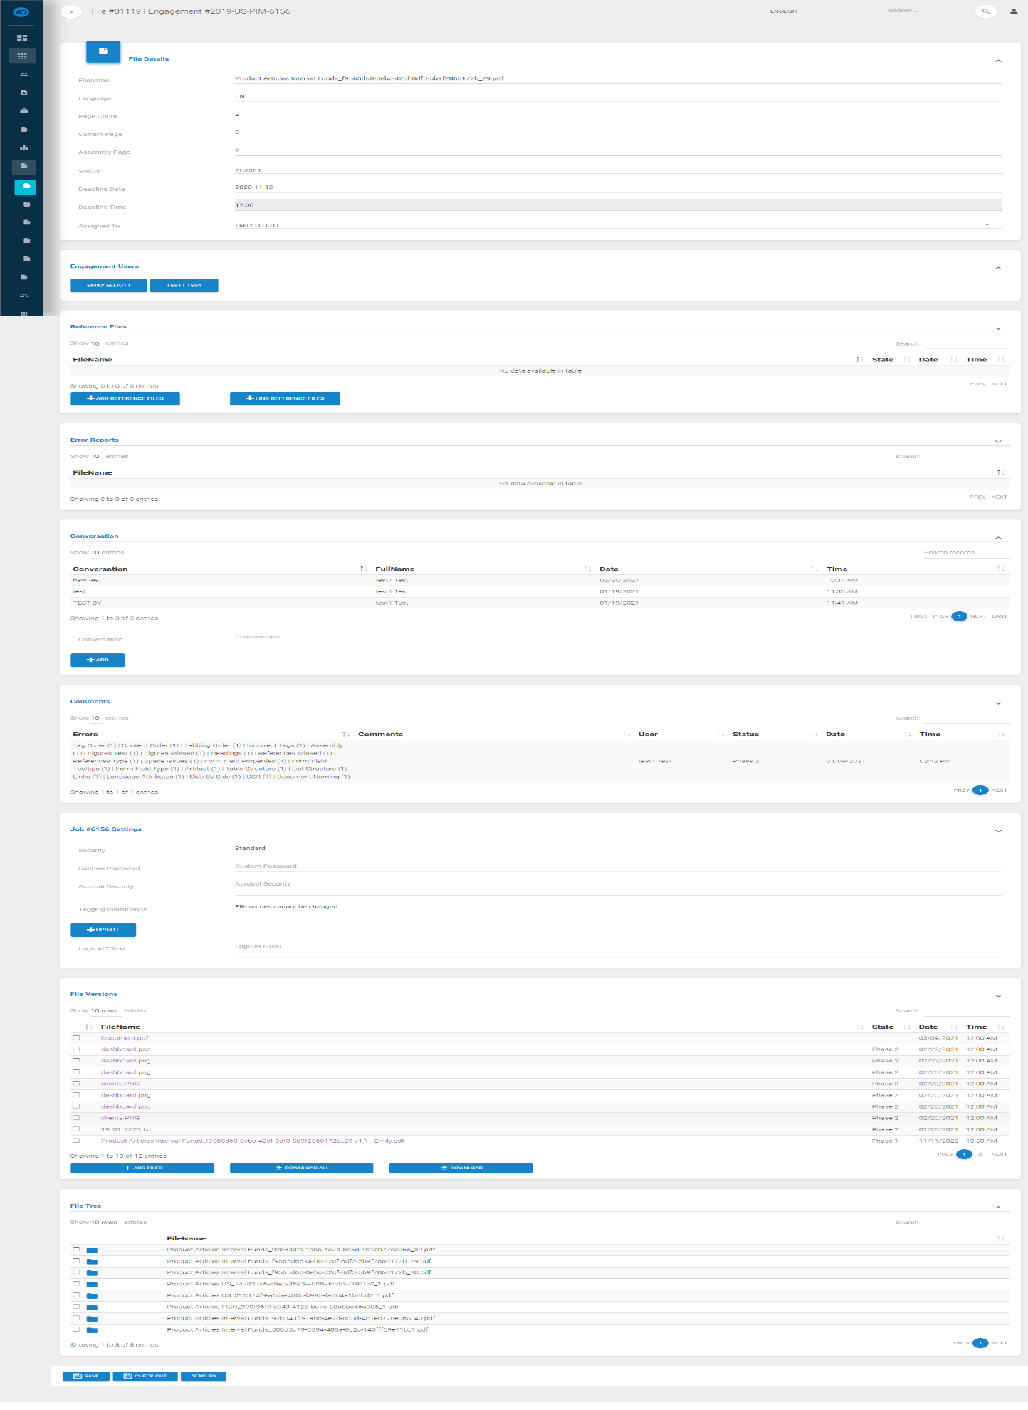

Following sections available in Phase 1 details page

* File Details:

Basic details of phase 1, phase 2, phase 4 and phase 5 shows in this section like File name, Language, Page count, Current page, Assembly page, Status, Deadline date, Deadline time, Assigned to.

* Engagement Users:

This section shows all users associated with this job file.

* Reference Files:

This section shows all reference files associated with this job file.

* Error Reports:

This section shows all error reports associated with this job file.

* Conversation:

This section shows all conversations associated with this job file.

* Comments:

This section shows all phase 1, phase 2, phase 3, phase 4 and phase 5 comments associated with this job file.

* Job Settings:

This section contains the job settings like Security, Custom password, Acrobat security, Tagging instruction, Logo alt text.

* File Versions:

This section shows all file versions associated with this job file.

* File Tree:

This section shows all job files associated with this job.

**Phase 4**

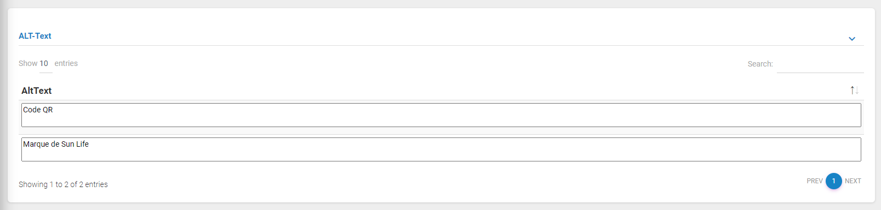

* Alt Text:

This section shows all alt text associated with this job file.

**Quotes**

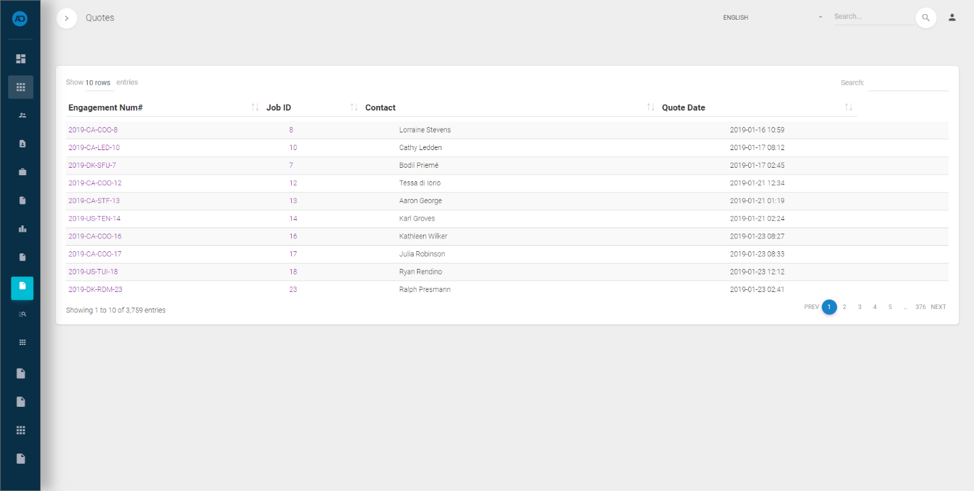

* **Quotes Dashboard**: This location where all quote are listed

**Search**

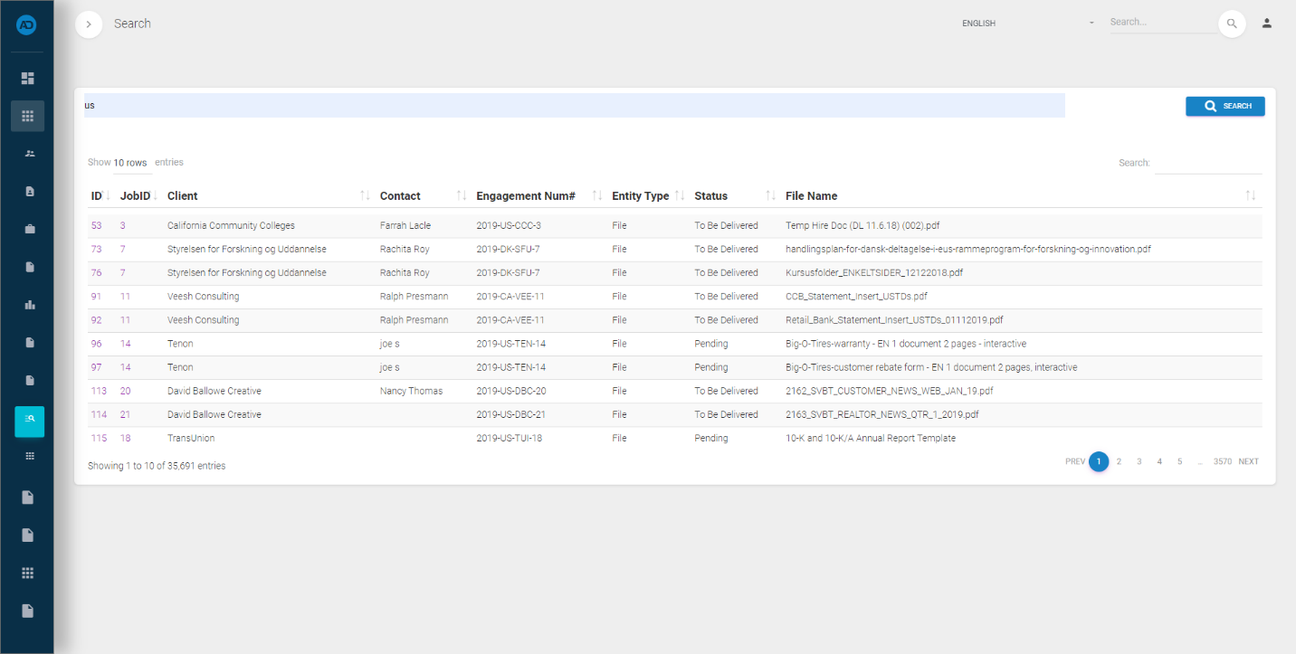

* **Search Dashboard**: This location where particular search (e.g clients or files) are listed

**Closed Jobs**

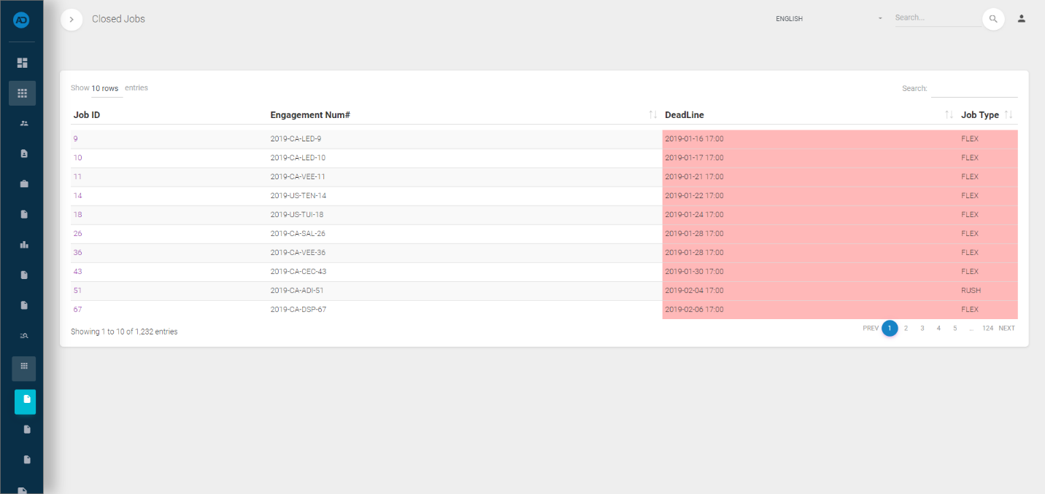

* **Closed Jobs Dashboard**: This location where all the job whose status is closed are listed

**Cancelled Jobs**

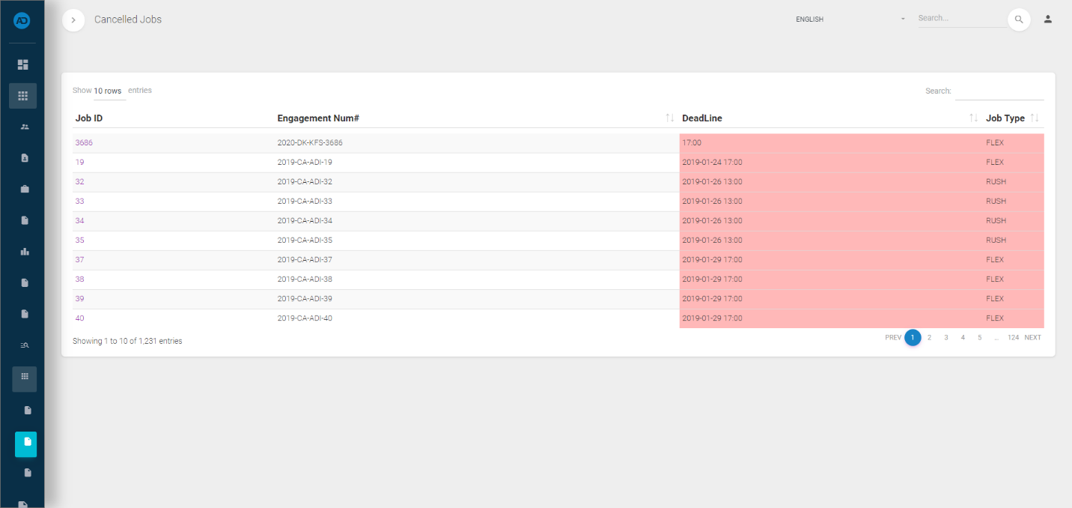

* **Cancelled Jobs Dashboard**: This location where all the job whose status is cancelled are listed

**Pending Invoices Jobs**

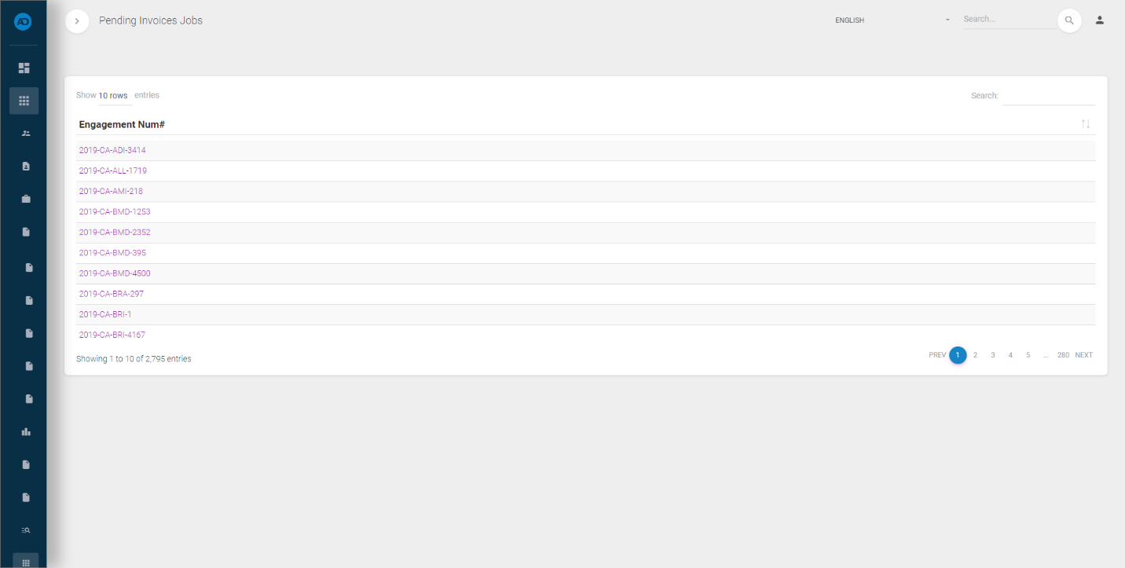

* **Pending Invoices Jobs Dashboard**: This location where all the job whose status is pending are listed

**ADScan**

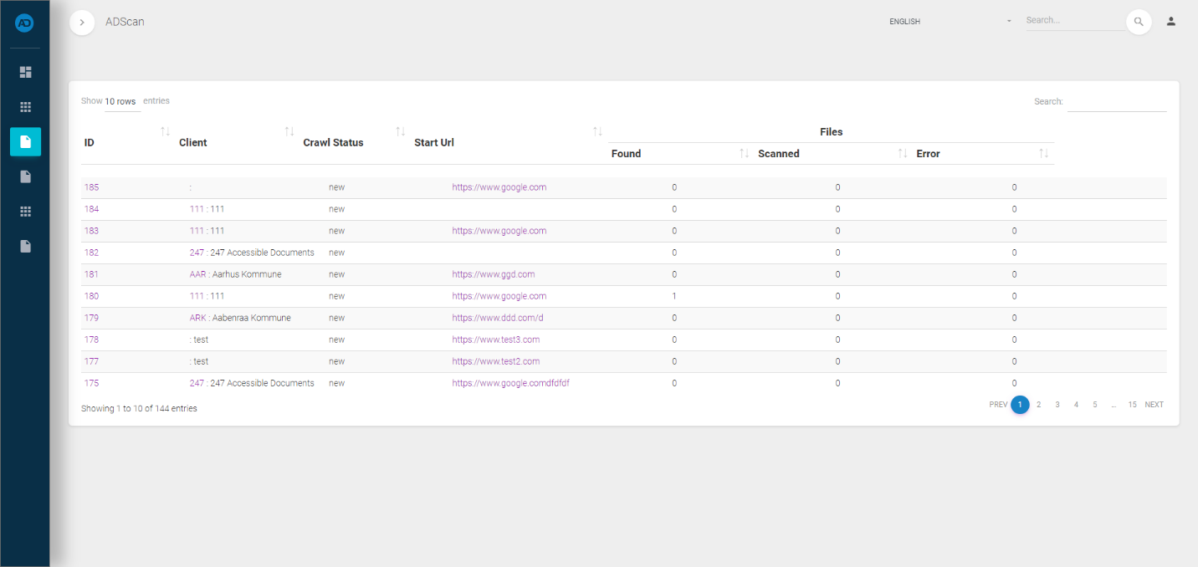

* **ADScan Dashboard**: This location where all the adscan crawls are listed.

**ADGateways**

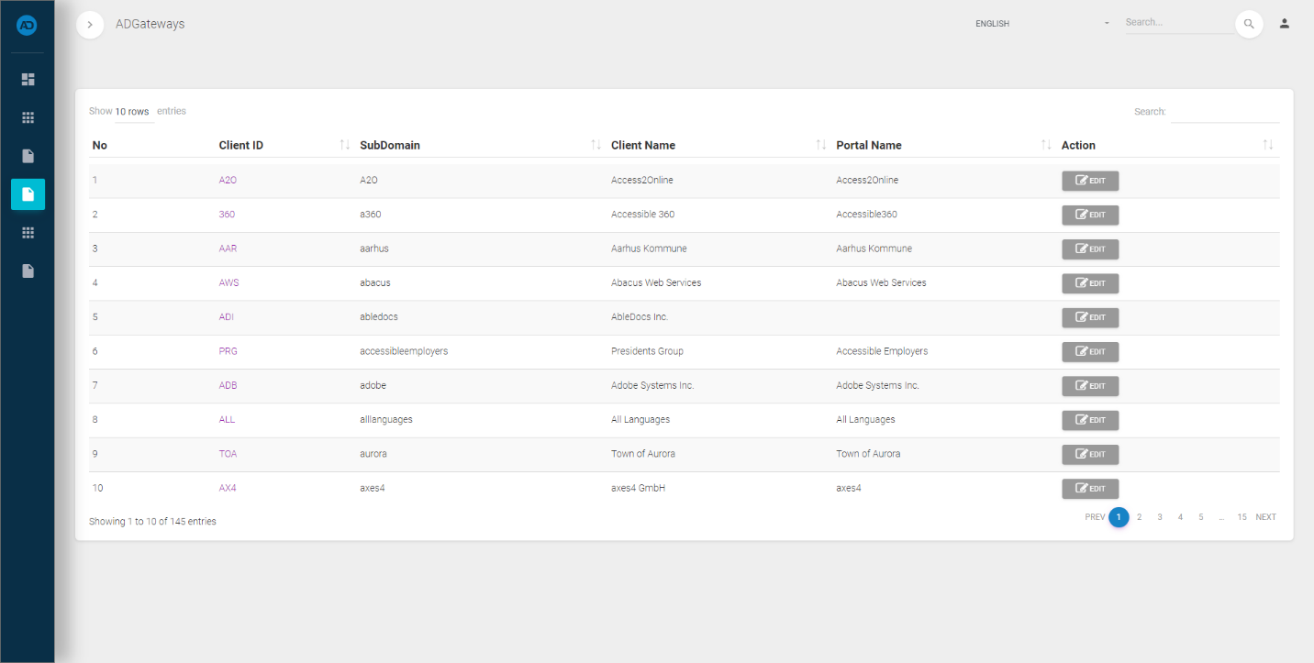

* **ADGateways Dashboard**: This location where all the adgateways are listed.

**Users**

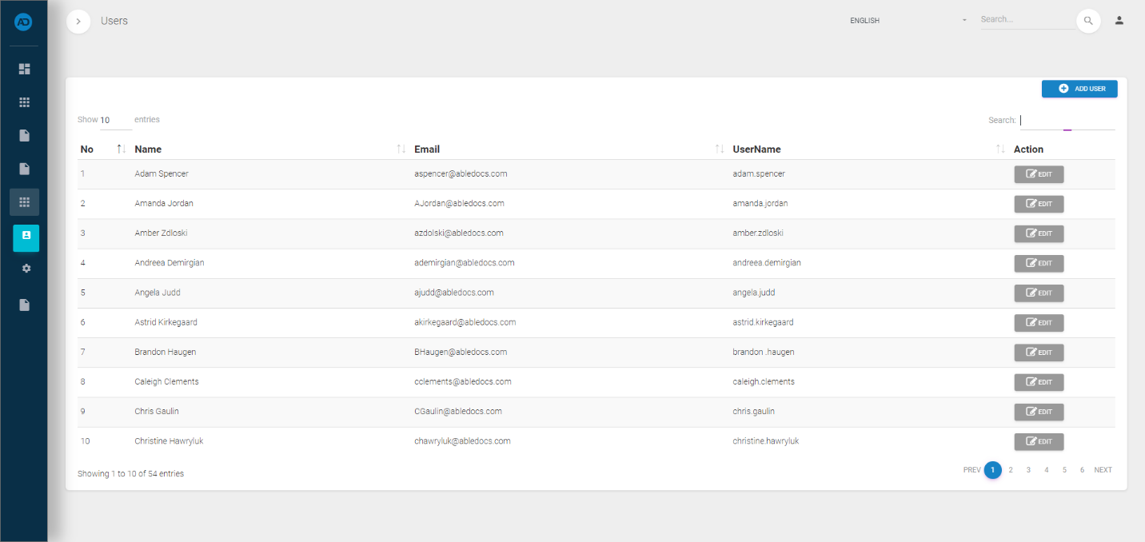

* **Users Dashboard:** This location where all the users are listed.

**Menu**

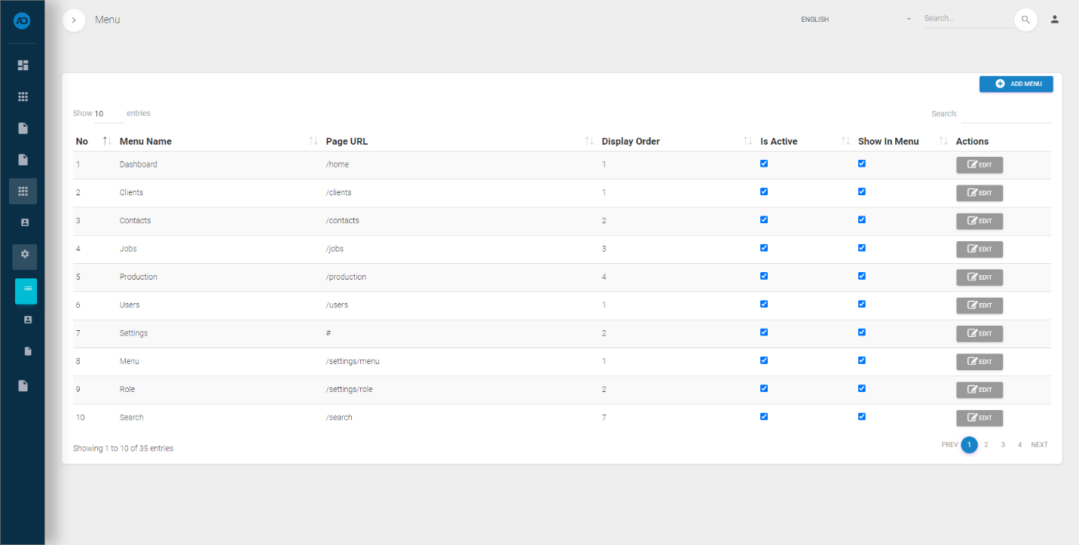

* **Menu Dashboard:** This location where all the menus are listed.

**Role**

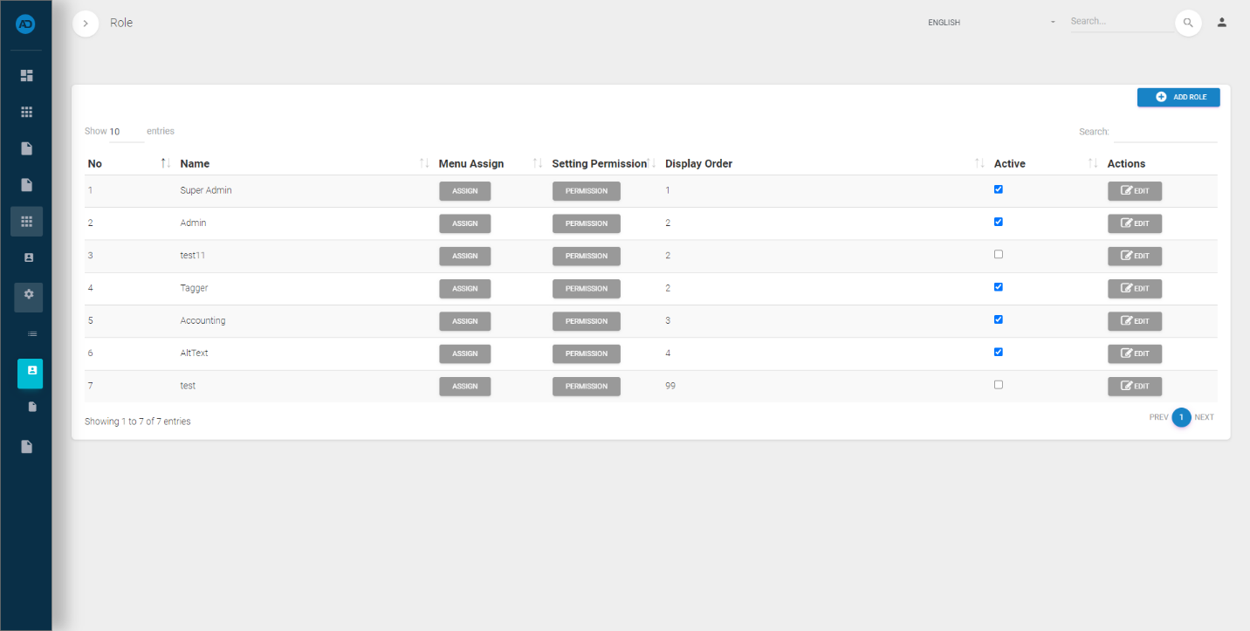

* **Role Dashboard:** This location where all the roles are listed.

**Quote Content**

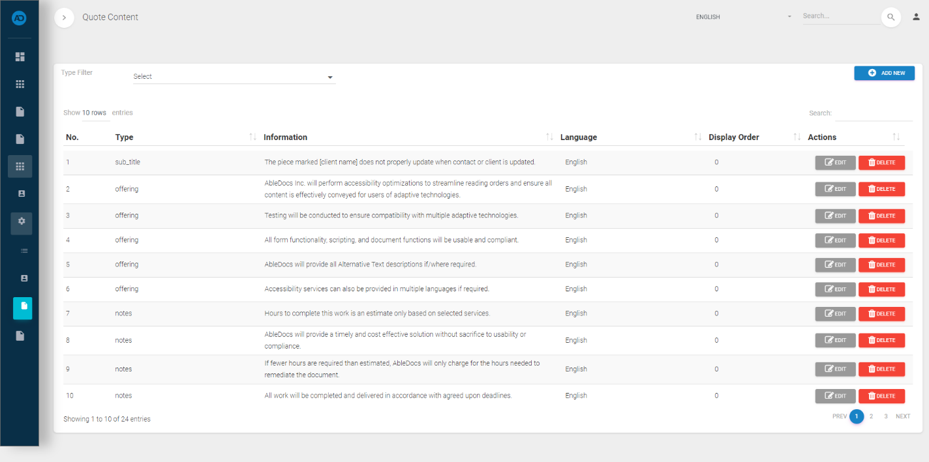

* **Quote Content Dashboard:** This location where all the quote content are listed.

**Bug Report**

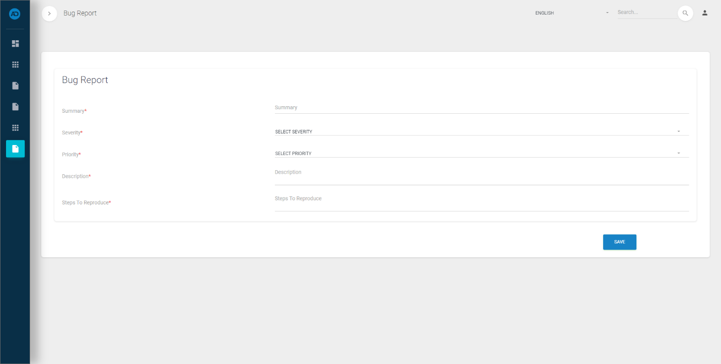

* **Bug Report Detail:**

Basic details of bug report shows in this section like Summary, Severity, Priority, Description, Steps to reproduce.

**Component description**

Following major components of Jobs

* Clients
  + Clients are any organisation or company. Job is created for a particular client. Clients have address details, Billing , job settings. One client can have multiple jobs.
  + Depending on client location, Tax value is calculated.
  + Depending on client Language , quote and invoices created.
* Contacts
  + Shows all contacts of a client for this particular job. There are different types of contacts defined for a job Like Billing contact, delivery contact.
  + Users are able to add multiple delivery contacts.
* Job Files
  + Shows all job files associated with this job. It has mainly three different categories: Source, Reference, Others.
  + Files are in the format of PDF, jpg or png.
* Users
  + Shows all User access or restricted for this job.

Following major components of Alt Text File

❖ Clients

➢ Depending on the client company name.

❖ Jobs

➢ Depending on job engagement num and tagging instructions.

❖ Job Files

➢ Depending on job file hour value, deadline and pages.

❖ Job Files Versions

➢ Shows all job files associated with this alt text file defined for a reference file.

❖ Alt Texts

➢ Shows all alt text associated with this alt text job client defined for a frequently used.

➢ Shows all alt text associated with this alt text file defined for a file alt text.

❖ Brand Image

➢ Shows all brand images associated with this alt text job client defined for a brand marks.

Following major components of Job File

❖ Jobs

➢ Jobs have job settings like security, custom password, acrobat security settings, tagging instruction, logo alt text .

❖ Jobs Files

➢ Jobs Files have file detail like file name, language, pages, current page, assembly page, status, deadline date and time, assigned to, alt text .

➢ Shows all jobs files associated with this file defined for a file tree.

❖ Jobs Files Versions

➢ Shows all jobs files versions associated with this file defined for a reference file.

❖ Jobs Files QC

➢ Shows all jobs files qc associated with this file defined for a comment.

❖ Jobs Files Final

➢ Shows all jobs files final associated with this file defined for a comment.

❖ Jobs Files Reviews

➢ Shows all jobs files reviews associated with this file defined for a comment.

❖ Conversations

➢ Shows all conversations associated with this file defined for a conversation.

❖ Error Report

➢ Shows all error report qc associated with this file defined for error reports.

Following major components of Clients File

❖ Clients

➢ Clients have client detail like company, code, address line 1, address line 2, country, state, city, post code, email, client since, note on client, api key, billing, job setting .

❖ Contacts

➢ Shows all contacts associated with this client defined for contacts.

❖ ADScan Crawls

➢ Shows all adscancrawls associated with this client defined for ADScan.

➢ ADScan is created for a particular client. ADScan have general detail, advanced, file. one

client can have multiple adscan crawls.

❖ ADGateways

➢ Shows all gateways associated with this client defined for Gateways.

➢ ADGateway is created for a particular client. Gateway have general detail, logo, standard fields, custom fields, advanced, file. one client can have multiple adgateways.

❖ ADLegacy

➢ ADLegacy is created for a particular client. ADLegacy have general detail, website logo, document stamp, advance. One adlegancy can have one client.

Following major components of Contacts File

❖ Contacts

➢ Contacts have contact detail like first name, last name, title, client, email, telephone, extension, language, billing contact, delivery contact, cell, note on contact and address detail.

❖ ADScan User

➢ ADScan user is created for a particular contact. ADScan user have contact general detail and address. One adscan user can have one contact.

Following major components of Review Files

❖ Jobs Files Reviews

➢ Shows all jobs files reviews associated with this file defined for a comment.

❖ Conversations

➢ Shows all conversations associated with this file defined for a conversation.

❖ Error Report

➢ Shows all error report associated with this file defined for an error report.

Following major components of QC Files

❖ Jobs Files Final

➢ Shows all jobs files final associated with this file defined for a comment.

❖ Jobs Files QC

➢ Shows all jobs files qc associated with this file defined for a comment.

❖ Conversations

➢ Shows all conversations associated with this file defined for a conversation.

❖ Alt Text

➢ Shows all alt text associated with this file defined for an error alt text.

Following major components of Final Files

❖ Jobs Files Reviews

➢ Shows all jobs files reviews associated with this file defined for a comment.

❖ Jobs Files Final

➢ Shows all jobs files final associated with this file defined for a comment.

❖ Jobs Files QC

➢ Shows all jobs files qc associated with this file defined for a comment.

❖ Conversations

➢ Shows all conversations associated with this file defined for a conversation.

❖ Alt Text

➢ Shows all alt text associated with this file defined for an error alt text.

1. **Document history**